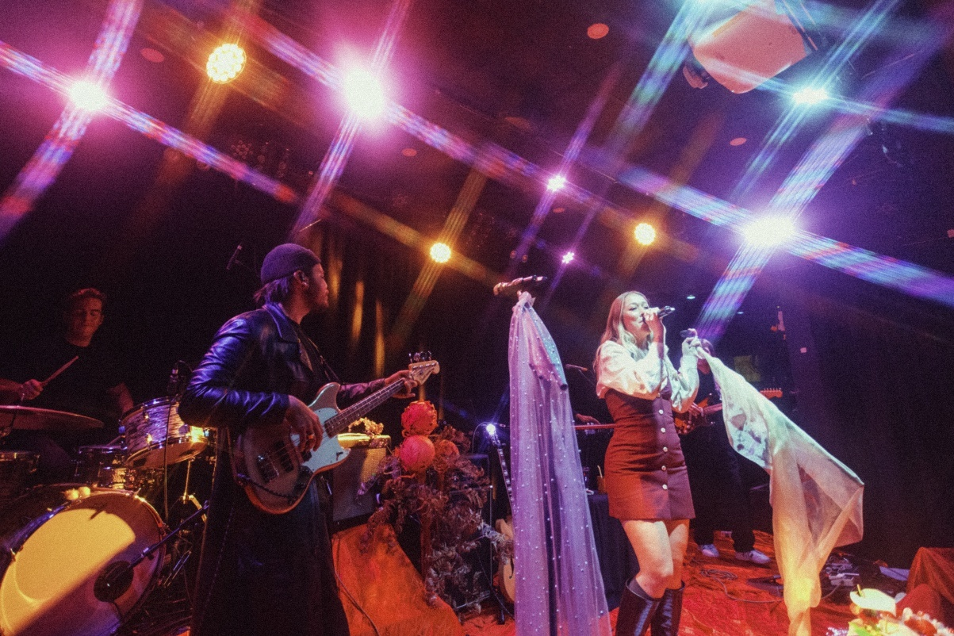**Velvet Bloom Turns Up the Volume on Accessibility with Sennheiser**

***With Sennheiser In-Ear Monitoring, MobileConnect, and the EW-DX Wireless System, the Melbourne-based band Velvet Bloom reimagines what an accessible live show can be.***

***Sydney, Australia, 3 September 2025 –*** On their national tour to celebrate the release of their debut album, Melbourne-based soul/pop band Velvet Bloom set out to deliver a sonically rich, emotionally immersive show that was just as inclusive off stage as it was impactful on it. With support from Sennheiser’s IE 4 and IE 100 Pro in-ear monitors, EW IEM G4 Wireless transmitter and receivers, EW-DX 835-S system, and MobileConnect, the band transformed their stage setup to deliver a more controlled, high-impact performance while also prioritising accessibility for fans with different hearing needs.

For lead vocalist and songwriter [Maddy Herbert](https://www.youtube.com/watch?v=MaeWhiF1EuM&ab_channel=Sennheiser), who was diagnosed in 2024 with otosclerosis, a progressive condition that causes hearing loss, the tour marked a shift in how the band approached sound, support and connection.

Rather than pull back, Velvet Bloom leaned into the challenge. With Sennheiser’s tools and a commitment to accessibility, they reimagined what their live shows could look and feel like for everyone in the room. “We want our shows to be as accessible as possible,” Maddy says. “So, people don’t have to feel like they are fighting just to experience live music. Everyone deserves to be in the room.”

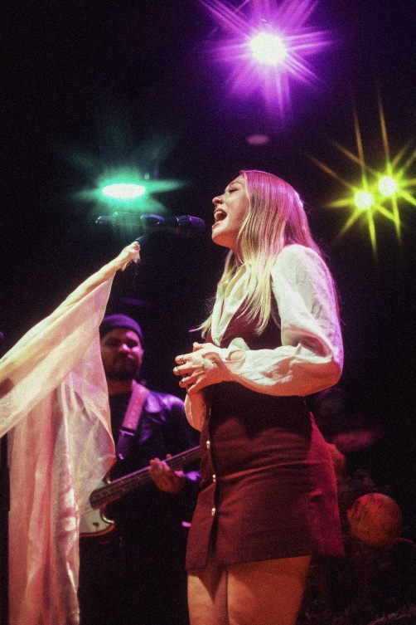

Maddy Herbert of Velvet Bloom performing live

**Listening more deeply**

Prior to their tour, the band often struggled with inconsistent sound from venue to venue. Maddy often found it difficult to monitor her vocals clearly, especially in louder rooms or unfamiliar setups. Over time, the inconsistency in monitoring started to affect her vocal stamina and made performing more challenging in unfamiliar environments.

“Before the in-ears, I’d often walk into a room and feel like I just wouldn’t be able to hear anything properly I’m feeling so much more confident about it now that I have more control of what I hear,” Maddy explains.

With Sennheiser In-Ear Monitoring and the EW-DX wireless microphone system, the band was able to personalise their stage mixes and stabilise the listening experience. “This is our first time using in-ears and wireless mics on tour as a band,” Maddy says. “The clarity that the microphones brought to our voices is something I have never experienced in a live setting.”

“With my hearing condition, it’s easy for stage sound to get muddy,” she adds. “Now I can personalise my mix and actually hear myself clearly, without adjusting anyone else’s levels.”

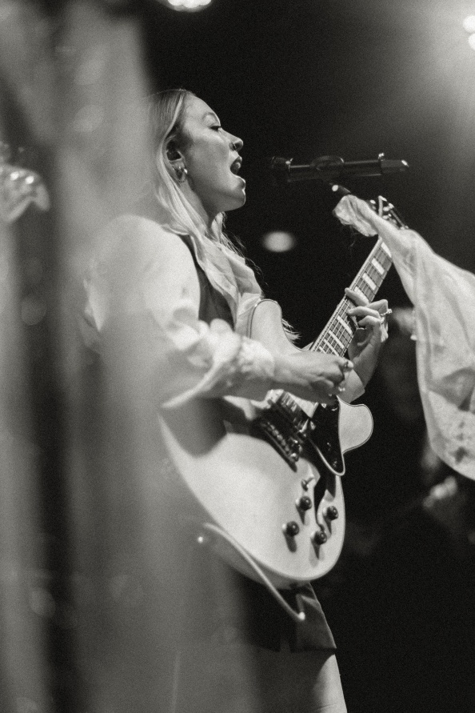

Maddy from Velvet Bloom performing live, singing with the Sennheiser EW-DX wireless mic and using Sennheiser in-ear monitors

**Sound that includes everyone**

Velvet Bloom’s shows have always prioritised emotional connection. With accessibility being a big part of that vision, [the band took steps](https://www.youtube.com/watch?v=I-ATNvNvm-8&ab_channel=Sennheiser) to ensure the audience’s experience felt just as considered as what was happening on stage.

The team also introduced additional access measures like communication boards, sensory kits, venue FAQs and compassion ticket, small but important details that helped make the experience easier and more welcoming for everyone. As Maddy shares, “access looks different for everyone. We just wanted people to feel welcome and supported, however they experience the show.”

They also briefly trialled Sennheiser’s MobileConnect, a system that allows audience members to stream the on-stage mix directly to their own phones or hearing devices via Wi-Fi. While not a major part of the tour, it was one of several steps the band explored in making their shows more accessible.

The wireless mic system also played a role in that experience. “It reduces tripping hazards, goes wherever the performer goes, and cuts through better than standard venue mics”, contributing to a setup that made her hear with clarity and perform with confidence.

**Performing with purpose**

The shift in the band’s setup was felt immediately. With greater mix control and monitoring consistency, Velvet Bloom delivered more confident, connected performances from venue to venue. And as accessibility became a shared value among the group, it naturally influenced how they prepared and performed together.

Band members Nick Morton (drums), Miguel Hutton (keys), Jay Jarome (bass and backing vocals), and Alex Marco (guitar) all contributed to refining the process and supporting a more expansive live experience.

Miguel and Alex from Velvet Bloom performing live with the Sennheiser EW-DX wireless system

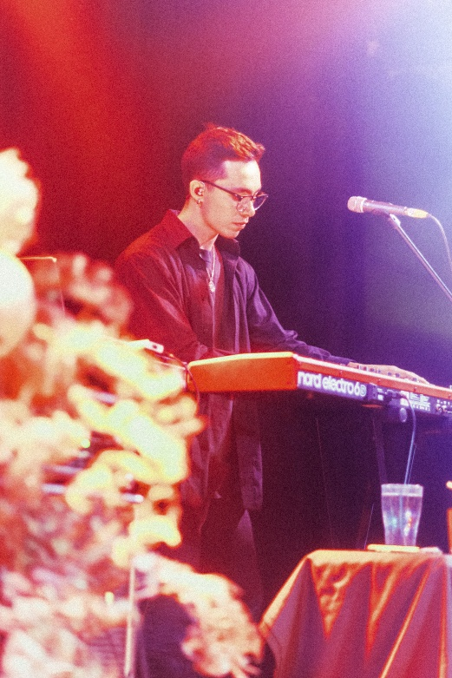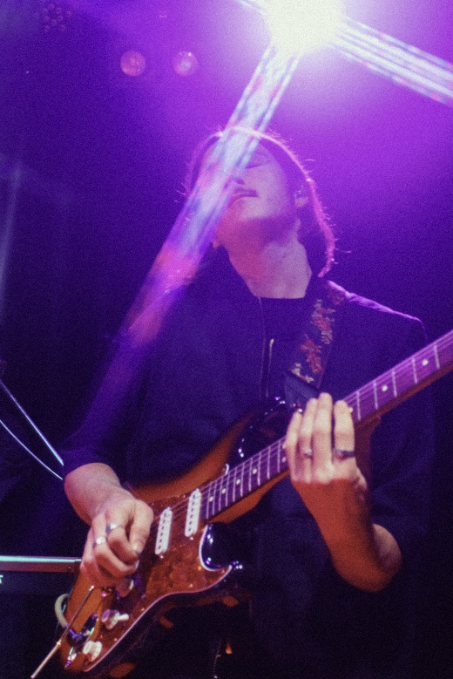

“We’ve had to think more deeply about how we play and support each other,” says Maddy. “It’s made our performances more intentional, and it’s brought us closer as a band.”

Velvet Bloom performing at Northcote Social Club with Sennheiser gear

**What Comes Next**

With the In-Ear Monitoring and EW-DX now part of their standard workflow, Velvet Bloom continues to build on what they’ve started. Their shows are designed not just to sound great, but to feel welcoming for every artist patron alike.

“There are lots of artists who perform with disability and chronic conditions,” Maddy says. “My access needs might look different from someone else’s, but they still need to be considered”

Maddy’s outlook has grown more hopeful through the support of the people around her, including her bandmates, as they’ve worked together to make live music more accessible.

That process has shaped how they think about touring and performing and less about following rules, and more about finding ways to make people feel welcome.

“We’re just trying to be thoughtful,” Maddy says. “If someone can walk into one of our gigs and feel considered, then we’ve done something right.”

For more information on upcoming shows, music and recent projects, visit: <https://www.velvetbloommusic.com/>

###

**About the Sennheiser brand – 80 Years of Building the Future of Audio**

We live and breathe audio. We are driven by the passion to create audio solutions that make a difference. This passion has taken us from the world’s greatest stages to the quietest listening rooms – and made Sennheiser the name behind audio that doesn’t just sound good: It feels true. In 2025, the Sennheiser brand celebrates its 80th anniversary. Since 1945, we stand for building the future of audio and bringing remarkable sound experiences to our customers.

While professional audio solutions such as microphones, meeting solutions, streaming technologies and monitoring systems are part of the business of Sennheiser electronic SE & Co. KG, the business with consumer devices such as headphones, soundbars and speech-enhanced hearables is operated by Sonova Holding AG under the license of Sennheiser.

[www.sennheiser.com](http://www.sennheiser.com)

[www.sennheiser-hearing.com](http://www.sennheiser-hearing.com)

|  |  |
| --- | --- |
| **Local Press Contacts**  Daniella Kohan  [Daniella.kohan@sennheiser.com](mailto:Daniella.kohan@sennheiser.com)  [+1 860 598 7420](tel:+1%20860%20598%207420)  Kirsten Spruch  kirsten.spruch@sennheiser.com  +1 (860) 598-7484 | Hotwire Australia  [sennheiseranz@hotwireglobal.com](mailto:sennheiseranz@hotwireglobal.com) |